BlueTech Almanac Webinar
2nd December 2021

At BlueTech Research we are always supporting our community by looking ahead - and we value the opportunity to share our unmatched insights into the global water technology market at this popular annual event.

Just as a farmers’ almanac contains a yearly forecast of vital information pertaining to the natural world, so BlueTech’s Almanac Webinar will present critical analysis carried out by our market intelligence experts. The trends predicted to have the most impact on the global water sector in 2022 and beyond will be revealed, along with the real-world implications and opportunities for companies facing these markets.

On the agenda

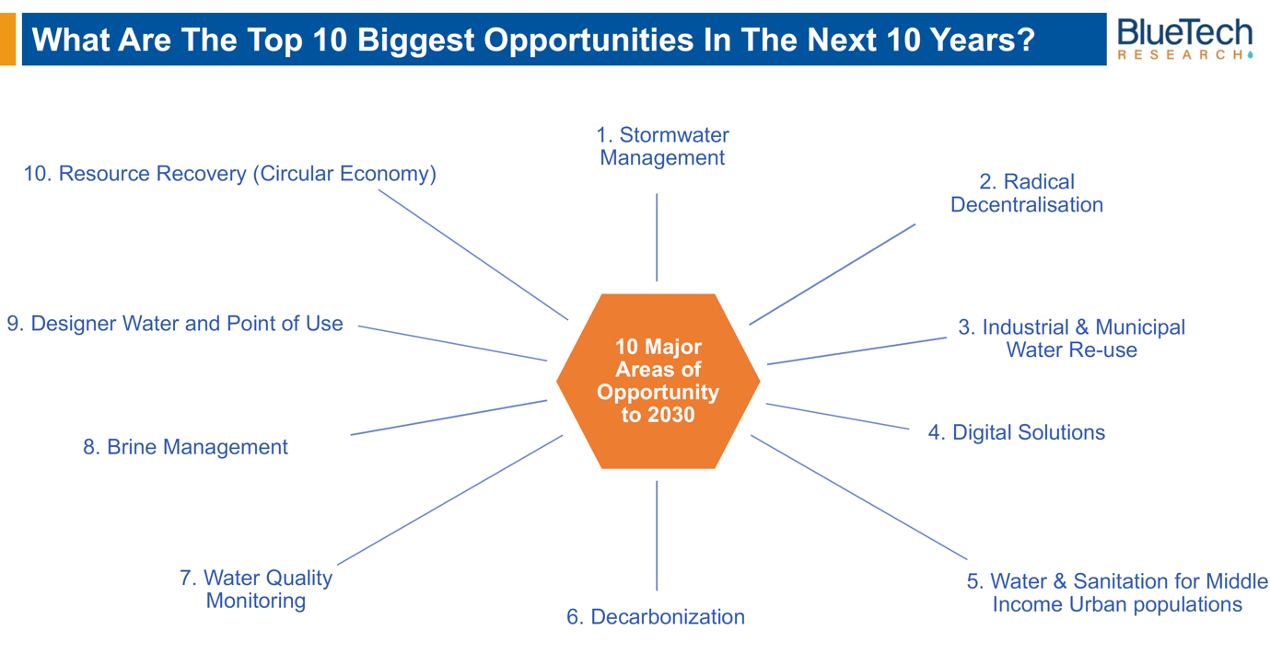

- Where BlueTech’s macro-trends in water could lead
- An update on the latest patents, investments, mergers & acquisitions
- Highlights from our weekly Analyst Alerts
- The rising stars in our water technology innovation tracker
- Learnings from BlueTech’s research portfolio
- Heads-up on the 2022 editorial calendar

The webinar will take place on 2nd Dec @ 08.00 Pacific / 11.00 Eastern / 16.00 GMT / 17.00 CET and you can register here.

For our partners in the Asia-Pacific region, we will run a separate session and you can register here.

If your company is already part of the BlueTech community, you are welcome to register now to secure your place.

If you’d like to find out more about the broader benefits of BlueTech membership for your organisation, email sarah.condon@bluetechresearch.com

At the end of another extraordinary year, we look forward to bringing the global water community together for this future-facing event.

Kind regards
Sarah

